Silhouette Example
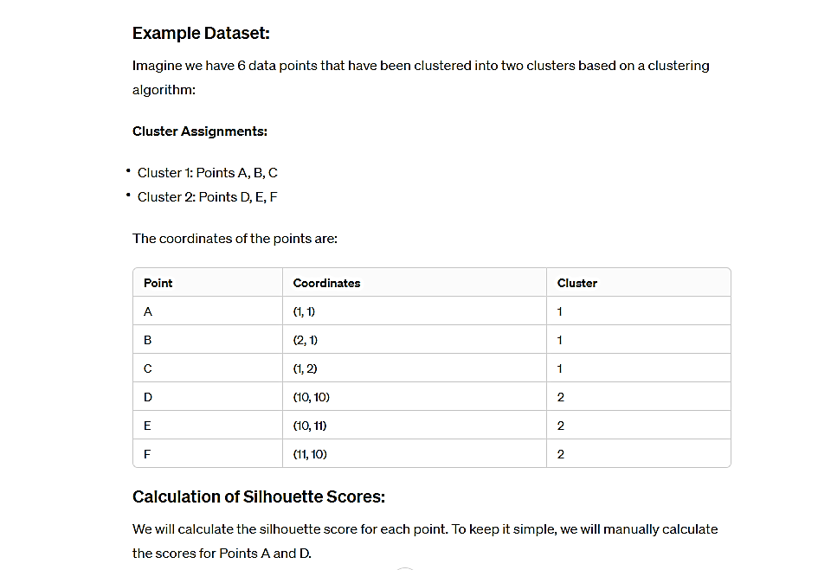

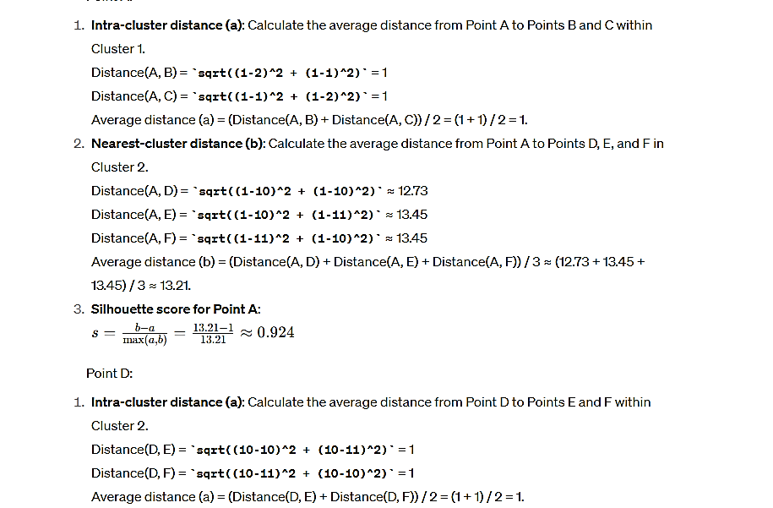
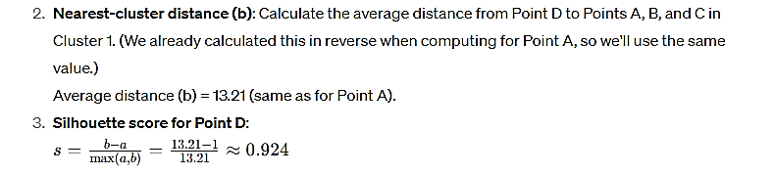
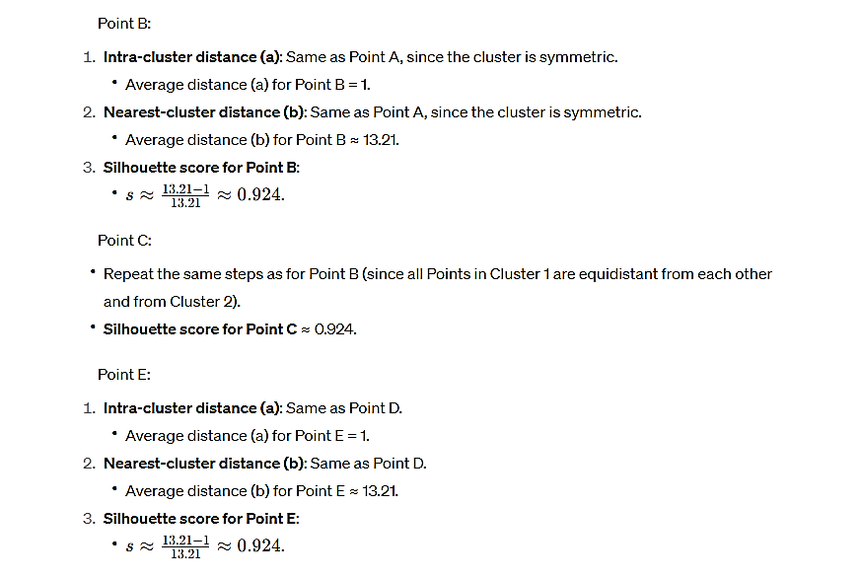
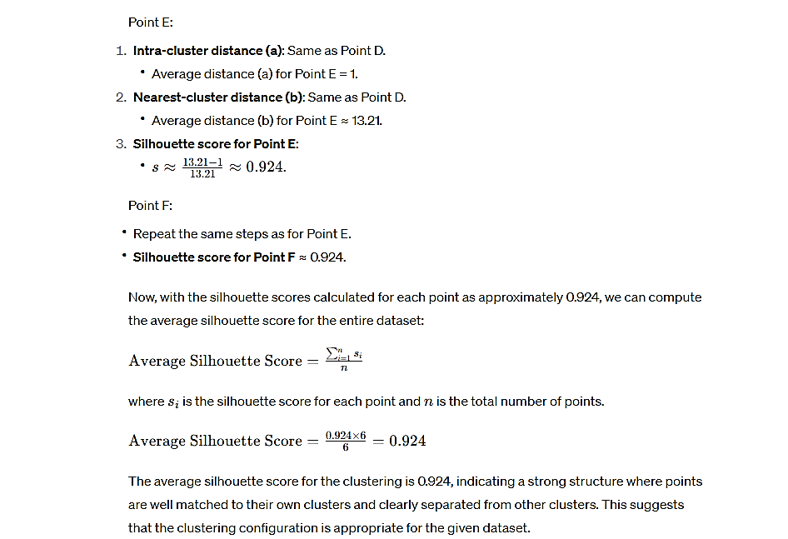
In cluster analysis, the distance between clusters can be calculated using methods such as single linkage and complete linkage:
- Single Linkage (Nearest Neighbor):
  - The distance between two clusters is the shortest distance between any member of one cluster to any member of another cluster.
  - Example: For clusters A: {(1,1), (2,2)} and B: {(5,5), (6,6)}, the distance is the smallest of the Euclidean distances between each point in A to each point in B.
- Complete Linkage (Farthest Neighbor):
  - The distance is the greatest distance between any member of one cluster to any member of another cluster.
  - Example: Using the same clusters A and B, the distance is the largest of the distances between each point in A to each point in B.

